Friday 13th April

vinod thorat

vthorat1@hawk.iit.edu

**JS Interview Challenge**

**Code Requirements**

1. As a user, I would like to have an application that shows a table of information.
2. When the user loads the page, they should see a table presented.
   1. The application should return data from <http://jsonplaceholder.typicode.com/posts>
3. When the user clicks on the header of a table column, it should sort the table.

Conditions (We will be looking for Best practices using your chosen framework A complete solution that addresses the user story Things that you can do to WOW us, Stylistic flair, Unit testing, when completed, submit your code to GitHub and send us a link to your solution!)

**Solution**

**Pre-run task:**

* Created html file with making call to the given URL.
* Run application using MAMP.
* Application having two files one is mail file with JavaScript code and other one is having sorting code.

**After run task:**

* Click on “Load” Button. It will render all the information from given URL in table format.

Attaching screenshots for the reference.

* Click on “RESET” Button to Set data to default.
* Sorting Applied on Headers Column (So when user click on Header column data get sorted accordingly).
* Style Sheet applied and did Unit testing at my end.
* Used **JavaScript** Only as you mentioned in requirement specification.

Please find attached screenshots for the reference.

**Screenshots**

1. **When we run Application at first time.**

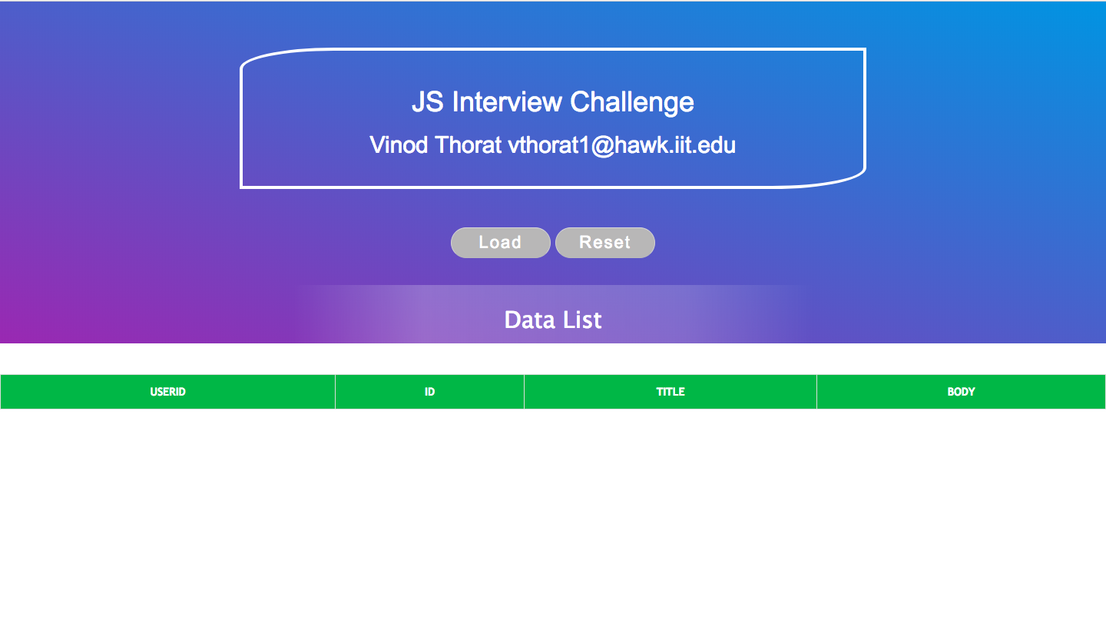

1. **After click on Load Button, it renders all the data from given URL. And shows in table format.**

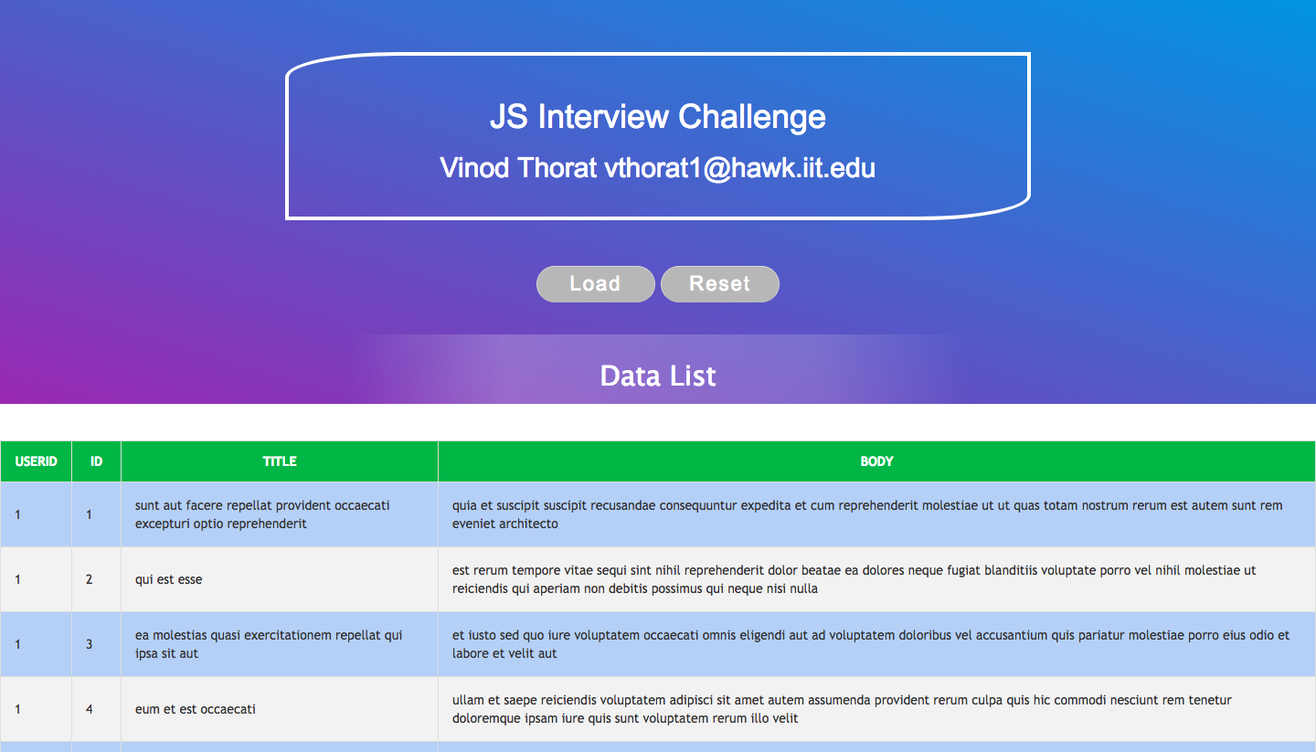

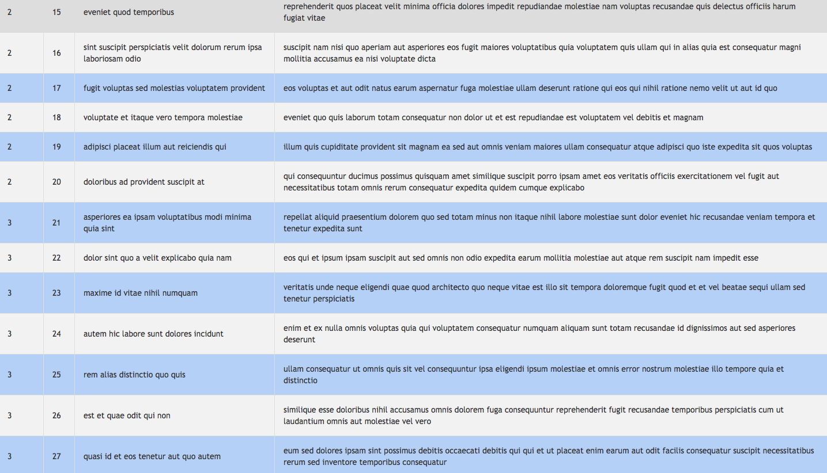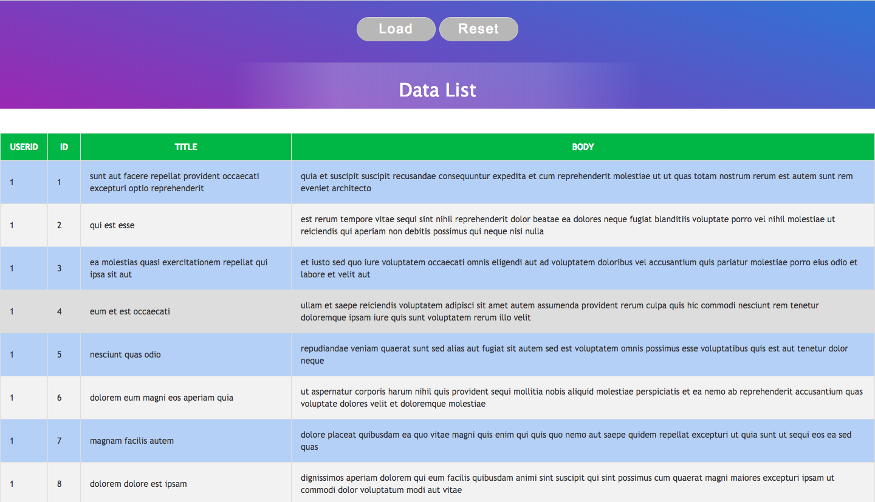

1. **After click on RESET Button, it reset all the data as same as on first load.**

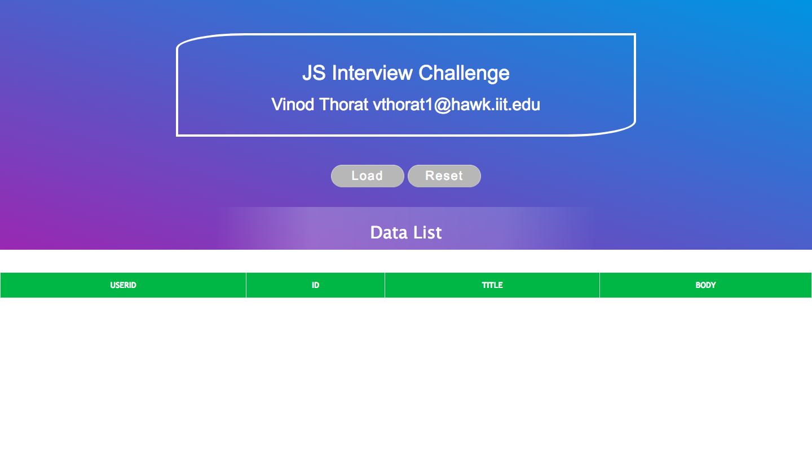

1. **After Click on Body Header it will Sort the data as per that column.**

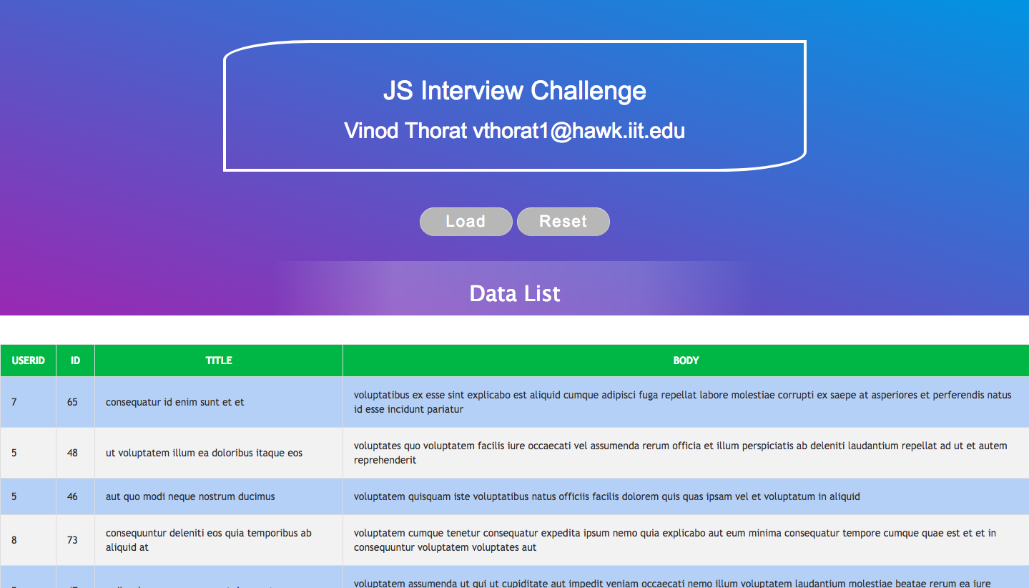

**5. After Click on “Title” Header it will Sort the data as per that column.**

